**Northwestern University eIRB+ Instructions**

1. **Obtaining a NetID**

Email [fsmhelp@northwestern.edu](mailto:fsmhelp@northwestern.edu) or call NU IT at (847) 497-4951 to check if you have an active NetID.

If you do not have a NetID, email Marianne Reed ([mereed@luriechildrens.org](mailto:mereed@luriechildrens.org)) to request one.

1. **Registering in eIRB+**  (more info: <https://irb.northwestern.edu/eirb>)

Determine if you will register on a computer off campus (non-Northwestern University building) or on campus (Northwestern University building).

**Off-campus registration (from a Lurie Children’s building):** Complete the eIRB+ support form: <https://irb.northwestern.edu/eirb-support>.

Complete all mandatory fields on the form. Select Off-Campus/SSL VPN Access for the topic. Explain you are trying to register off-campus in the Question/Comments section. If submitted on a business day, the request will usually be responded to within the same business day or the following business day.

After you have registered in eIRB+, you will be able to access the system off-campus using the VPN. You will be automatically routed to the VPN option. It is only when you first register off-campus, that you will need to request eIRB+ Support.

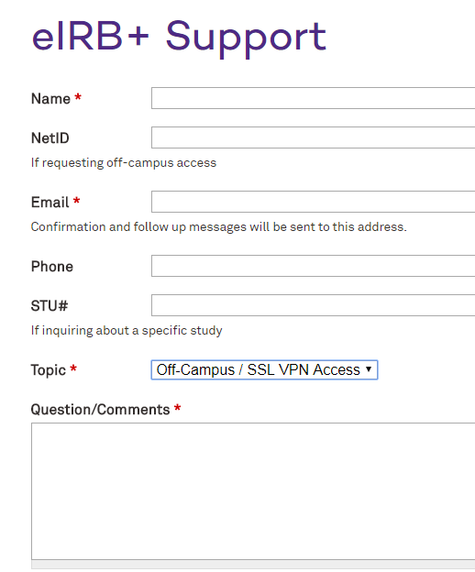

**On-campus (from a Northwestern Building or Computer Network):** Access the eIRB+ Overview page: <https://irb.northwestern.edu/eirb>

Click on the eIRB+ icon. Then complete the mandatory fields: Name, Department, NetID, Business Telephone, Email and Mailing Address. Additional help available here: <https://irb.northwestern.edu/eirb/register>

1. **Education requirements**

Email a certificate of your Human Subjects Research Training to [irbtraining@northwestern.edu](mailto:irbtraining@northwestern.edu). Your training will then be uploaded into your profile.

1. **Starting a new study in eIRB+**

Log into eIRB+ from the Northwestern University website: <https://irb.northwestern.edu/>

Click on the eIRB+ icon.

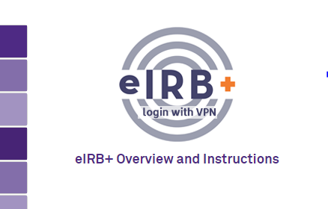

If you are directed to VPN, log in with your NetID and Password.

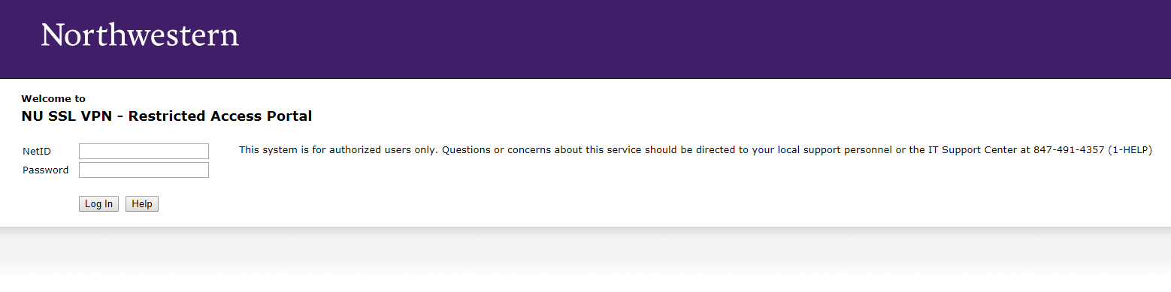

Choose eIRB+ Production.

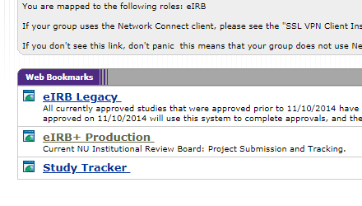

Log in to eIRB+ with your NetID and password.

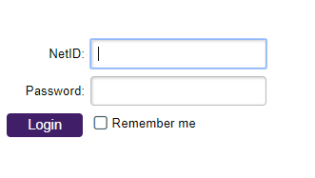

Create your profile by entering requested information.

Click “Create New Study” at the top left of the page.

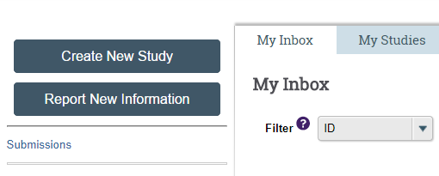

1. **Completing the Abbreviated Application**

**Basic Information Page (Page 1):**

**Only asterisked (*) questions are mandatory. These instructions provide guidance on only the required questions in the eIRB+ application.**

* Question 1 and 2: Add the study and short title. These two titles can be the same, or the study team can insert a nickname into the short title field. Be sure to include **(xIRB)** before the study title and short title.

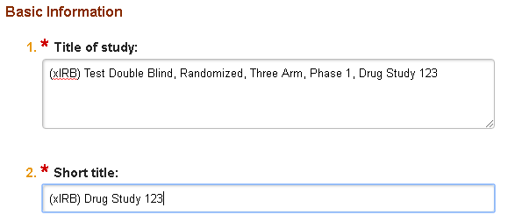

* Question 3: Provide a brief description of the study. An example of a description is written below.

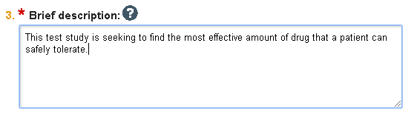

* Question 4: Select the study type, Social Behavioral or Biomedical.

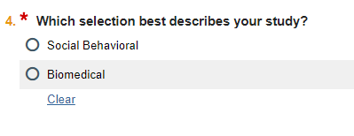

* Question 5: Select the PI (click on the three dots to search for the PI name).

If the PI is not listed, they are not registered in eIRB+ and should see part 1 and 2 of these instructions.

Email [eirbsystem@northwestern.edu](mailto:eirbsystem@northwestern.edu) for any additional assistance.

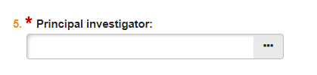

* Question 6: Select “yes” as the answer (an external IRB will be the IRB of record for this study).

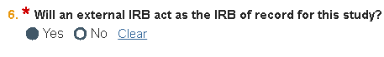

* Question 7: Select Multi-site study.

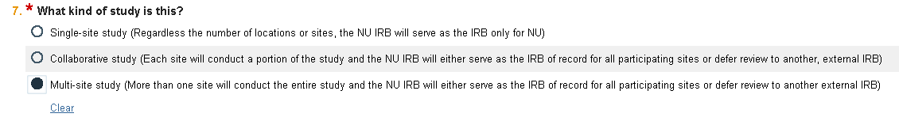

**Page 2: External IRB Page:**

* Question 1: Click on the box with three dots (…) and select Lurie Children’s Hospital of Chicago.

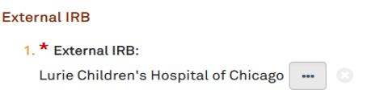

* Question 2: Enter the Lurie Children’s IRB number.

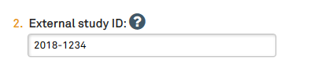

* Question 3-5: Upload the approval letter and enter the dates of study approval at Lurie Children’s.

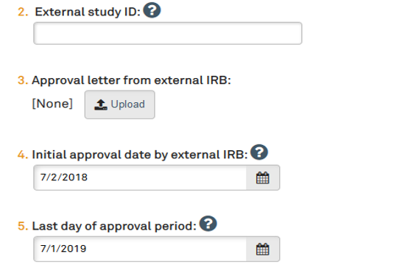

* Question 6: Type in “Per the Lurie Children’s and Northwestern IRB Authorization Agreement (IAA), this study is using Lurie Children’s as the IRB of record.”

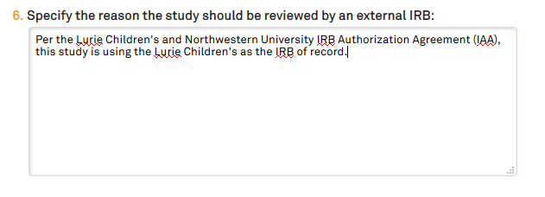

**Page 3: Sources of Funding and Other Support**

* Question 1: Add the funding source for the study. Click on the box with the plus sign **(+Add)** to search for the funding source. If there is no external funding source and the study is being funded by the investigator, select “Lurie Children’s Hospital of Chicago”. If the funding source is not listed, select “Other” and type in the source, or email [eirbsystems@northwestern.edu](mailto:eirbsystems@northwestern.edu).

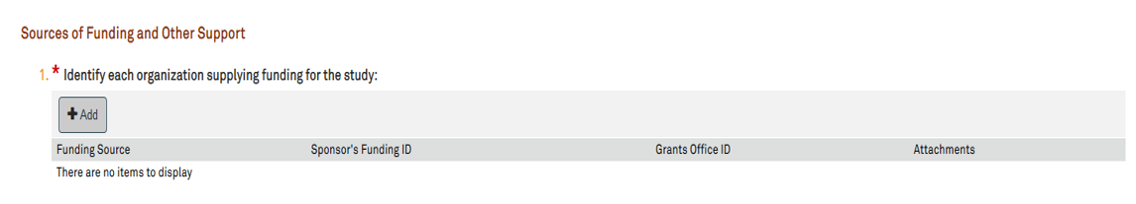

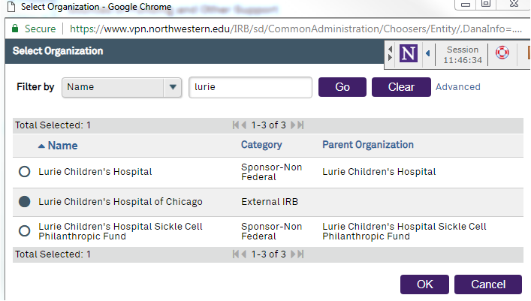

**Page 4: Study Scope**

**Complete the subsequent sections of the eIRB+ application as pertinent to the research study (drug and device questions).**

**Page 5: Final Page**

**Once you click Finish, you will be taken back to the main study home page but please note the submission is NOT complete yet.**

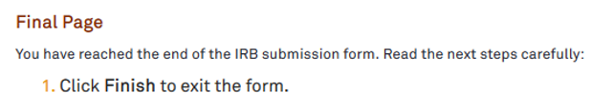

**Important: You must complete the local site application in order for the study to be submitted to the Northwestern University IRB!**

**Below is a view of the study home page.**

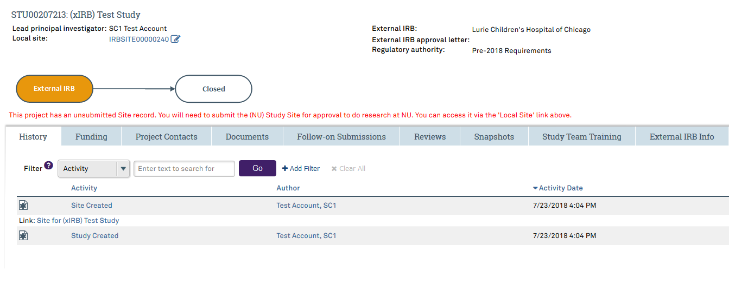

**To begin the local site application, click on the edit button (pencil & paper image) next to “Local Site” on the top left of the page.**

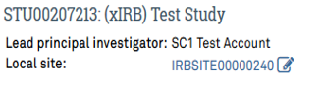

* This is where you will need to complete the local site submission. The local site submission will ask similar questions that you just completed. However, it is also the page where you will list study personnel at Northwestern University and upload the remaining study documents.
* Once you are finished with the local site application, click “Finish” to go back to the study home page to submit the application. The “Submit” link can be found on the left hand side of the page (screen shot on next page).

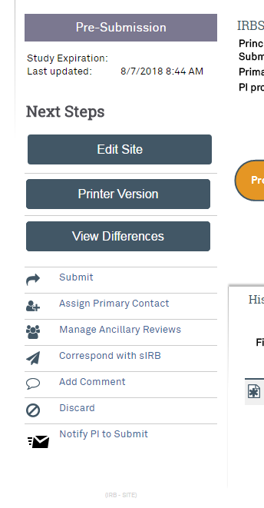

*\*If you have any suggested edits or notice the instructions are no longer accurate, please email* [*irb@luriechildrens.org*](mailto:irb@luriechildrens.org)