Lurie Children’s Cayuse IRB Instructions

- Education requirements and obtaining access to Cayuse IRB
☐ Complete Human Subject Research Protection and Good Clinical Practice education requirements, as applicable. See the IRB Education page for further information.
☐ Send a completed Cayuse Access Form​ to irb@luriechildrens.org.
- Starting a new study in Cayuse IRB
These instructions provide guidance on how to complete the required questions in Cayuse IRB when Lurie Children’s will be the IRB of Record for Northwestern University or an Affiliate.
☐ Log in: https://luriechildrens.cayuse424.com/
☐ Choose “Cayuse IRB”
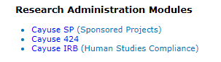
☐ Read and then close the black announcement banner (click on close button, top right).

☐ Click “+New Study” in upper right corner of screen.

☐ Study Details Page: Add the full study title and click the check mark to save. The IRB # will be generated.
☐ Click “+New Submission” in upper right corner of screen and select “Initial” from the drop down menu.
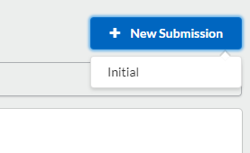
☐ Click “Edit” to begin the study application (first button on left).
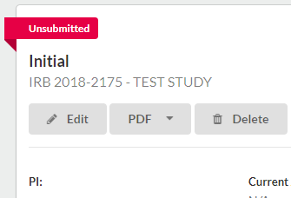

☐ Complete Section 1: General Information:
- Choose the type of submission in Section 1 General Information, item A.1.
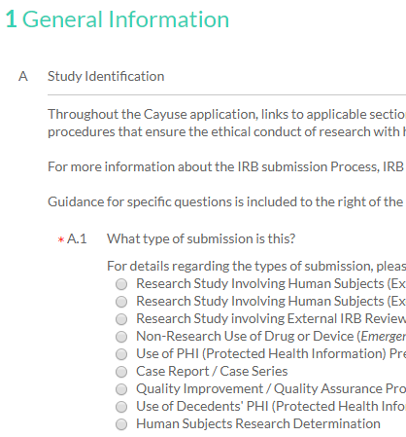
☐ Complete the required questions as prompted:
- Questions from Section B involve study personnel. In the Cayuse IRB application, list only investigators and study personnel who will be engaged in research at Lurie Children’s. Northwestern University faculty and staff will be listed in the eIRB+ application.

- B.1: Select the PI, clicking on “Find People”, then searching for the Investigator.
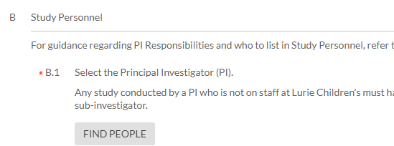
- B.2: You will be automatically entered as the primary research contact. Please make sure you keep yourself on the study so you can return to it as needed and can edit and submit applications for IRB approval.

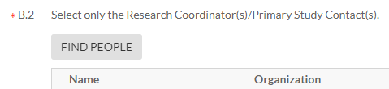

☐ Complete Section 2, Study Settings:
- A.1: Select which locations the study will be conducted at by Lurie Children’s Investigators.
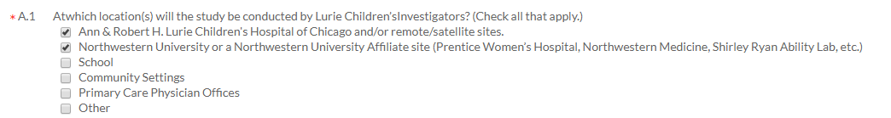
- A.2: This question asks if Lurie Children’s is serving as the IRB of record. Answer “Yes, Lurie Children’s will serve as the IRB of record for another site”

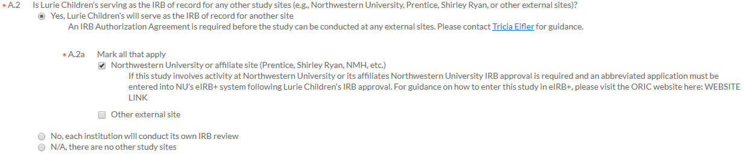

- A.2a: Then select the subcategory option: “Northwestern University or Affiliate Site.”

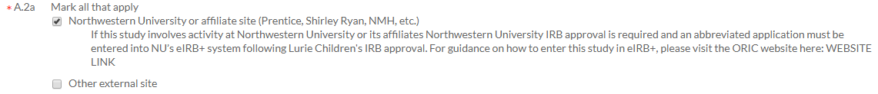

☐ Complete the remainder of the application as is pertinent to the study.
☐ Click submit, and correspond with the IRB staff until IRB approval letter is received.
☐ Download the eIRB+ Instructions from the website and create an abbreviated study in the Northwestern University eIRB+ system.

*If you have any suggested edits or notice the instructions are no longer accurate, please email irb@luriechildrens.org

